Question 5 [6 Points]

Create a shell script sync.sh to compare two directories dirA and dirB.Your script should:
• List files present only in dirA
• List files present only in dirB
• For files with the same name in both directories, check whether their contents matchDo NOT copy or modify files.Use diff, cmp, or checksum techniques.
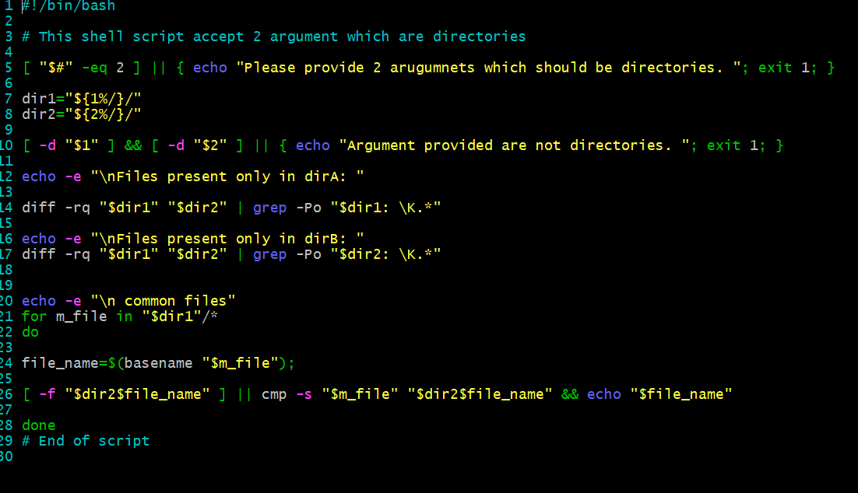
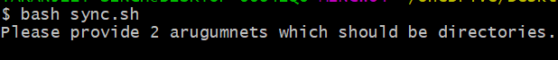
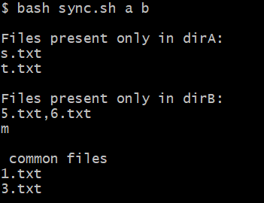
Explanation: So above script helps to compare two directories, and I am handling error really well. Also use cmp and diff command with grep with -Po parameter to display the out on the screen in clean format. I separates file present in direction a/ not in directory b/ and vice versa. Also putted the files common in both. Gor desired output, screenshots are attached.

